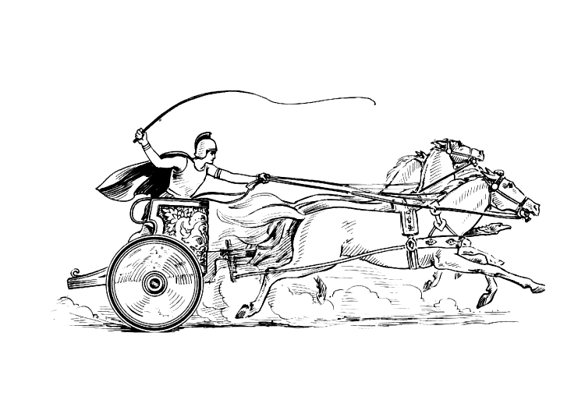
Mancetter Parish Council
Parish Clerk: Elane Higgins
Parish registered address:
Mancetter Memorial Hall, Old Farm Road, Mancetter.
CV9 1QN
Telephone 01827 722552
Email: parishclerk@mancetter.org.uk
www.mancetter.org.uk

Meetings are held bi-monthly usually on the fourth Tuesday of the month, at St Peter’s Church Mancetter, starting at 7pm.
Members of the public are welcome to attend.

MEETING DATES 2022 / 2023

26th July 2022
21st September 2022
Informal Parish Meeting for Residents and Local Community Groups (at Mancetter Memorial Hall)
27th September 2022
22nd November 2022
24th January 2023
28th March 2023
25th April 2023
Official Annual Parish Meeting for Residents
and Local Community Groups
16th May 2023
Annual Parish Council Meeting for New Term of Office.

